C211 Study Guide Questions V4

Competency 1: Business Decision-Making in the Global Environment
Globalization (Peng Chapters 1, 5, 6, 11)
- List and explain the two core perspectives for global business in detail with examples for each.
  - Resource based view states that firm’s specific resources and capabilities lead to firm’s success and failures. All emphasis on the firm’s abilities.
  - Institution based view – formal and informal institutions or the rules of the game, leads to firm’s success or failure. These are external factors that are out of their control.
- What is globalization? Explain the three views on globalization.
  - The close integration of countries and the people of the world.
    - New Force – Sweeping through the world in recent times (A Western ideology focused on exploiting the world through MNEs (Multinational Enterprises).
    - A long-run historical evolution – a long run of evolution since the dawn of human history. Its one-directional
    - A pendulum – Swings from one extreme to another from time to time. Not recent nor one-directional)
- What is FDI? What are horizontal and vertical FDI?
  - FDI – Investment in, controlling, and managing value-adding activities in other countries (ownership, control)
  - Horizontal FDI – Duplicating home country activities at the same value-chain stage in a host country.
  - Vertical FDI – Upstream and downstream moves in different value-chain stages in a host country (producing or selling)
- What is the OLI advantage? Explain, providing an example of each.
  - FDI Advantage (OLI) – Ownership, location, and internalization advantages
    - Ownership – the multinational firm possession and leveraging certain valuable, rare, or hard to imitate and organizationally embedded overseas (VRIO).
    - Location – those enjoyed by firms because they do business in certain places. Unique to places such as natural or labor resources or its location. You’re either seeking market or seeking resources.
    - Internalization – the replacement of cross-border markets, such as exporting and importing, with one firm locating in two or more countries. This is to avoid cross-border issues like taxes and tariffs.
- What are the three political views on FDI? (Explain)
  - Radical – Is hostile to FDI and treats FDI as an instrument of imperialism and is a vehicle for exploitation of domestic resources by foreign capitalists and firms.
  - Free Market – suggests that FDI, unrestricted by government intervention, will enable countries to tap into their absolute or comparative advantages by specializing in the production of certain goods and services.
  - Pragmatic Nationalism – viewing FDI as having both pros and cons and only approving FDI when the benefits outweigh the cost.
- Carrier (HVAC company) decided to close its manufacturing plant in Ohio and move it to Mexico.
  - Which country is the host, and which is the home?
    - Host - Mexico
    - Home – United States
  - What are the costs and benefits of FDI to the home country?
    - Costs – capital outflow and job loss
    - Benefits – repatriated earnings from profits, increase exports of components and services to the host country, learning via FDI from operations abroad.
  - What are the costs and benefits of FDI to the host country?
    - Costs – Loss of sovereignty, adverse effects on competition, and capital outflow
    - Benefits – Capital inflow, technology spillover, advanced management know-how, job creation
- What is dumping, and what are anti-dumping duties?
- What is collusion, and what characteristics of a market make collusion difficult?
  - Collusion – Collective attempts between competing firms to reduce competition.
    - Market characteristics – Few firms, existence of a price leader, homogenous products, high barrier to entry, high market commonality.
- How do resources and capabilities influence the competitive dynamics of a business? (Give an example)
  - A number of resource-based essentials, informed by VRIO framework drives decisions and actions associated with competitive dynamics.
    - Value – firms must create value when engaging rivals
    - Rarity – nature or nurture, certain assets are rare, generating significant advantage in competitive dynamics
    - Imitability – Try to imitate successful rival
    - Organization – some firms are better organized for competitive actions.
- What is resource similarity and how does this impact competitive dynamics? (Give an example)
  - Resource Similarity – The extent to which a competitor possesses strategic endowment comparable, in terms of both type and amount, to those of a local firm. (e.g. IBM and Amazon in cloud computing)
    - Market commonality – overlap between two rival markets
    - Theory of attack/counterattack – set of actions to gain competitive advantage (attack)/set of actions in response to an attack (counterattack)
    - Cooperating and Signaling – Some firms choose to cooperate in order to reduce the competitive intensity. Short of illegally colluding, firms resort to signaling.
- Explain the four strategies that local firms can take to fight MNEs.
  - Contender – firm engaging in rapid learning and then expand overseas
  - Defender – centers on local assets in areas where MNEs are weak
  - Dodger – cooperating through joint ventures with MNEs
  - Extender – leveraging homegrown competencies abroad

International Trade and Foreign Exchange Market (Peng Chapters 5, 7, 10)
- Define each of the following: trade deficit, trade surplus, and balance of trade.
- Explain the three types of classical (static) international trade theories.
- Explain the three types of modern (dynamic) international trade theories.
- What is an exchange rate?
- What are the determinants of supply and demand for an exchange rate market?
- What is purchasing power parity (PPP)?
- What does it mean if a country’s currency depreciates? Appreciates?
- What are fixed, pegged, floating (clean), and managed (dirty) float exchange rates?
- How can changes in the interest rate affect the exchange rate? And how do changes in the inflation rate affect the exchange rate? Explain clearly.
- Describe the three types of currency transactions presented in this course. Which one is considered currency hedging?
- If a company seeks to limit foreign exchange rate exposure in the forward direction, what is the most effective way to do this?
- What is strategic hedging?
- Give an example of a first and late mover. List each mover’s advantages and disadvantages.
- What are the two modes of foreign market entries? Describe each scale of entry with examples.
Competency 2: Political and Economic Forces
Political and Economic Forces (Peng Chapter 2)
- How do institutions reduce uncertainty?
- Discuss and compare the three pillars (regulatory, normative, and cognitive) under the institution-based view of global business.
- What are the two core propositions that lie at the root of the institution-based view of global business?
- Describe the political system of Totalitarianism, including the distinct types of totalitarian regimes.
- Describe the political system of Democracy.
- Compare and contrast the different legal systems. Give an example of countries that fit into each system.
  - Civil Law
  - Common Law
  - Theocratic Law
- Compare and contrast Market Economy, Command (Centrally Planned) Economy, and Mixed Economy.
  - Which is the most flexible?
  - Which has private property, and which has public owned means of production?
- What is Political Risk? Describe and provide an example.
- What are the business implications for conducting international business in countries with different political and economic systems?
- What are property rights, and how are they protected?
- How is intellectual Property protected? What are the different types of intellectual property protections?
- What are the reasons why intellectual property protections are critical in today’s global business environment?

Competency 4: Microeconomics and Macroeconomic Principles
Microeconomic Principles (Mankiw Chapters 4 & 5)
- What is demand?
- Why is the demand curve typically downward sloping?
- What are the factors that shift the demand curve?
- What is supply?
- What are the factors that shift the supply curve?
- If the price of cereal decreases,
  - What happens to the demand for milk?
  - What happens to the equilibrium price and quantity for milk?
  - Draw the supply/demand diagram for milk to help answer your question.
- If demand and supply both increase, how do the equilibrium price (P) and quantity (Q) change? Explain.
- What is the price elasticity of demand?
  - What does it mean if a good is elastic? Give an example.
  - What does it mean if a good is inelastic? Give an example.
- What is income elasticity of demand?
  - What do the values of income elasticity tell us about whether a good is a normal good or an inferior good?
- What is cross-price elasticity of demand?
  - What do the values of cross-price elasticity tell us about whether two goods are substitutes or complements?

Competency 3: Economic Decision-Making by Firms and Customers
Consumer Behavior (Mankiw Chapter 21)
- What is a budget constraint? What information is being represented by the constraint?
- How would a budget constraint be impacted by the following:
- an increase in income
- if the price of one of the goods increased
- if the prices of both goods decreased by 10%.
- What does an Indifference Curve show/represent?
- What are the 4 properties of indifference curves?
- Given the picture below, answer the following questions:
  - What is the point most preferred? Explain why.
  - Explain why this person would be equally happy at points B and D.
  - What would be the optimal consumption point? Explain why.
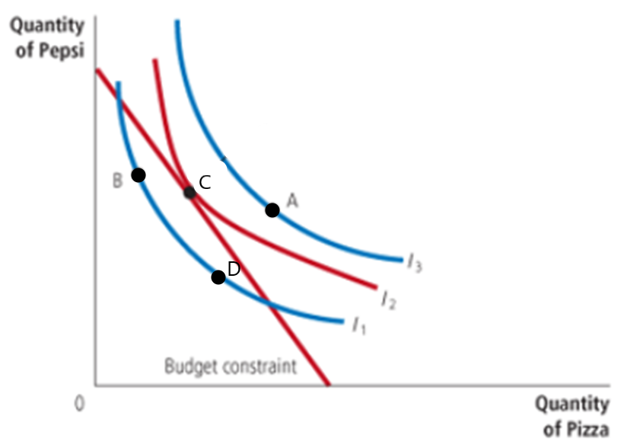

Firm Behavior Under Different Market Structures (Mankiw Chapters 13-17)
- Total cost is made of two types of costs; what are they? Give an example of both types of costs. (Hint: it’s not implicit/explicit.)
- Describe Marginal Cost in your own words. What is the equation?
- What are Average Fixed Costs and Average Variable Costs? How do they relate to Average Total Costs?
- What is the relationship between Marginal Cost and Average Variable and Average Total Costs?
- If Dave’s company has a total cost of $83 when output is 10, and a total cost of $96 when output is 11,
- What is the marginal cost of producing the 11th unit?
- If the price of Dave’s product is $10, should Dave increase production, decrease production, shut down temporarily. Why?
- What is the difference between short run and long run?
- How does a competitive firm determine whether to shut down in the short run? What about in the long run?
- Describe the difference between monopolistic competition and monopoly (monopolist).
- Describe the three types of barriers to entry that can lead to a monopoly. Give an example of each.
- How does a monopoly determine the profit maximizing quantity to produce and the price to charge?
- In the scenario below, two oil companies are deciding whether to set their production at a high level or a low level. The numbers in the box are the profit outcomes from each decision.
  - What would be the collusion agreement in this game?
  - What does the Prisoner’s Dilemma tell us would be the Nash Equilibrium of this game?
  - Explain in your own words why this is a Nash Equilibrium.
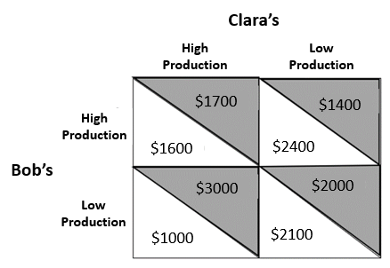
- What does the Prisoner’s Dilemma tell us about the formation and longevity of collusion among firms?
- What is an oligopoly with only two firms called?
- Which market structures are considered imperfect competition?
- Complete the following table of market structure characteristics as you go through each chapter. Understanding the relationships between the markets and similarities and differences in characteristics is important.

 | Perfect Competition | Monopolistic Competition | Oligopoly | Monopoly (Monopolist)
Example of firms in this market
Number of Firms
What is the shape of a firm’s demand curve?
Products are Differentiated, Identical, Both, or Unique
Are firms price-takers or price-makers?
What is the relationship between Price and MR? (Refer to Sec 15-2c & Sec 14-1b)
What is the firm’s rule for Profit Maximization?
Are there any barriers to Entry?
Can firms make Short-run economic profits?
Can firms make Long-run economic profits?
Are firms likely to advertise?
Do firms produce a Socially Efficient level of Output? (Mankiw Ch15-3A, 16-2C)
Are firms likely to collude?

Competency 4: Microeconomics and Macroeconomic Principles
Macroeconomic Principles (Mankiw Chapters 29 & 34)
- What is the difference between fiscal and monetary policy?
- What is the Federal Funds rate?
- What are total bank reserves?
- What is the discount rate (discount window rate)?
- What is the required reserve ratio?
- What are open market operations?
- What is aggregate demand?
- What three actions could the Federal Reserve take to DECREASE the money supply?
  - What impact will the decrease in the money supply have on the Federal Funds rate?
  - What impact will the change in the interest rate have on aggregate demand?
- The economy is experiencing a recession. What are three ways the Federal Reserve can DECREASE the interest rate (federal funds rate)?
  - What impact will that have on the aggregate demand? Explain briefly.
- What is the crowding out effect and how might it affect interest rates and aggregate demand?
- What is the expenditure multiplier effect?
- If the government uses fiscal policy to decrease government spending, what impact will this have on aggregate demand?
- If the government uses fiscal policy and decreases taxes, what effect will this have on aggregate demand?
- What are automatic stabilizers? Give two examples.
Competency 5: Assessing Global Economic Performance and International Trade
Measuring Economic Performance (Mankiw Chapters 7 & 23)
- Define consumer surplus in your own words.
  - Which area(s) represent consumer surplus on the following graph? Why?
- Define producer surplus in your own words.
  - Which area(s) represent producer surplus on the following graph? Why?
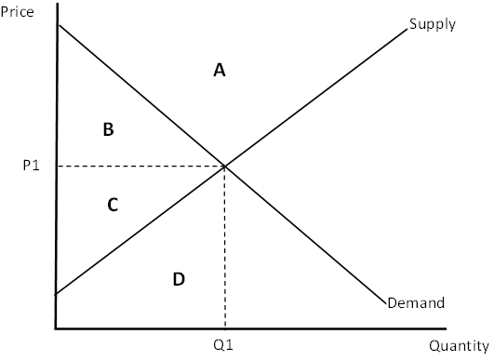

- What is total surplus?
  - What can it tell us about market efficiency?
- Define gross domestic product (GDP).
- Describe the four components of GDP with examples.
- Explain why national income must be equal to national expenditure in the economy as a whole?
- Given the following items, state whether or not they would be included in calculating GDP for the US for 2024 (assume all are in 2024 unless otherwise stated).
  - A new house built in 2024.
  - Paying tuition for school.
  - The eggs iHop restaurant buys.
  - Computers that Google purchased.
  - Cars that Ford produces in Mexico.
- What is the GDP Deflator?
- Why are transfer payments such as social security not counted in the government expenditures portion of GDP?
- In what ways might GDP not be a good measure of well-being?

International Trade (Mankiw Chapter 9)
- Why do countries choose to trade?
- When a country opens up to free trade of a good, the country will be an exporter or an importer of that good.
  - If the country chooses to export the good, what happens to the domestic price of the good, and who are the winners and losers?
  - If the country chooses to import the good, what happens to the domestic price of the good, who are the winners and losers?
- When an import tariff is imposed, explain how each of the following is impacted.
  - Domestic price
  - Domestic sellers
  - Domestic buyers
  - Domestic government
  - Foreign Producers
- Using the answer to #3, discuss the concept of deadweight loss relating to concepts of consumer and producer surplus when a tariff is imposed.
- Explain the five arguments against free trade.

